**IMPLEMENT THE AR FOR TUTOR AND VR FOR CLASS ROOM PROJECT USING UNITY SOFTWARE**

### PROJECT REPORT – S11BPB51 AUGMENTED AND VIRTUAL REALITY

Submitted in partial fulfillment of the requirements for the award of Bachelor of Engineering degree in Computer Science and Engineering

By

**Taufeeq Ali SK (Reg. No –43110782)**

**Surya S(Reg. No – 43110783)**

**Yugasarathy S(Reg. No – 43110786)**

**Jayavignesh S(Reg. No – 43110781)**

**Vishal T(Reg. No – 43111026)**



**DEPARTMENT OF COMPUTER SCIENCE AND ENGINEERING**

## SCHOOL OF COMPUTING

SATHYABAMA

### INSTITUTE OF SCIENCE AND TECHNOLOGY (DEEMED TO BE UNIVERSITY)

**CATEGORY - 1 UNIVERSITY BY UGC**

**Accredited “A++” by NAAC I Approved by AICTE JEPPIAAR NAGAR, RAJIV GANDHI SALAI, CHENNAI - 600119**

### OCTOBER - 2025



**DEPARTMENT OF COMPUTER SCIENCE AND ENGINEERING**

**BONAFIDE CERTIFICATE**

This is to certify that this Project Report is the bonafide work of **Taufeeq Ali SK  
(Reg. No – 43110782)** who carried out the Project entitled “**IMPLEMENT THE AR FOR TUTOR AND VR FOR CLASS ROOM PROJECT USING UNITY SOFTWARE**” under my supervision from June 2025 to August 2025.

**Internal Guide**

**Dr SYLVIA GRACEJ, M.E, Ph.D.,**

**Head of the Department**

**Dr. L. LAKSHMANAN, M.E., Ph.D.,**

**Submitted for Project Examination held on**

**Internal Examiner External Examiner**

### DECLARATION

I, **Taufeeq Ali SK(Reg. No – 43110782),** hereby declare that the Project Report entitled **“IMPLEMENT THE AR FOR TUTOR AND VR FOR CLASS ROOM PROJECT USING UNITY SOFTWARE”** done by me under the guidance of **Dr SYLVIA GRACE J ,M.E,Ph.D,** is submitted in partial fulfillment of the requirements for the award of Bachelor of Engineering degree in **Computer Science and Engineering**.

### DATE:

**PLACE: Chennai SIGNATURE OF THE CANDIDATE**

### ACKNOWLEDGEMENT

I am pleased to acknowledge my sincere thanks to **Board of Management** of **Sathyabama Institute of Science and Technology** for their kind encouragement in doing this project and for completing it successfully. I am grateful to them.

I convey my thanks to **Dr. L. Lakshmanan, M.E., Ph. D.**, **Dean and Head**, School of Computing, for providing me necessary support and details at the right time during the progressive reviews.

I would like to express my sincere and deep sense of gratitude to my Project Guide **Dr SYLVIA GRACEJ, M.E, Ph.D.,** for her valuable guidance, suggestions, and constant encouragement paved way for the successful completion of my project work.

I wish to express my thanks to all Teaching and Non-teaching staff members of the **Department of Computer Science and Engineering** who were helpful in many ways for the completion of the project.

**ABSTRACT**

The use of immersive technologies like Augmented Reality (AR) and Virtual Reality (VR) in education has changed traditional learning methods. This project seeks to implement AR and VR solutions to improve the teaching and learning experience in a digital classroom environment. The AR part serves as a virtual tutor, letting students interact with 3D educational models, animations, and real-time guidance on their mobile or tablet devices. By adding digital content to the physical world, the AR tutor makes abstract concepts clearer and easier to grasp, especially in subjects like science, math, and engineering. At the same time, the VR part creates a fully immersive virtual classroom. Here, students can attend simulated lectures, explore interactive learning spaces, and take part in collaborative activities without any physical limits. Using VR headsets, learners enter a 3D virtual space that imitates real-world classroom dynamics, which boosts engagement and helps in understanding concepts better. This dual approach uses Unity 3D, AR Foundation, XR Interaction Toolkit, and other immersive tools to build an intuitive and interactive platform. The project shows how AR and VR can overcome the challenges of traditional classrooms, providing personalized, scalable, and engaging learning experiences for the future of education.

v

**TABLE OF CONTENTS**

|  |  |  |  |  |
| --- | --- | --- | --- | --- |
| **Chapter No** | **Title** | | | **Page No.** |
|  | **ABSTRACT** | | | v |
|  | **LIST OF FIGURES** | | | vii |
|  | **LIST OF TABLES** | | | viii |
| 1 | **INTRODUCTION** | | | **1** |
|  | 1.1 | Background of the Study | | 1 |
|  | 1.2 | Problem Statement | | 2 |
|  | 1.3 | Objectives of the Project | | 3 |
|  | 1.4 | Purpose and Innovation | | 4 |
| **2** | **REQUIREMENTS ANALYSIS** | | | 5 |
|  | 2.1 | | Feasibility Studies / Risk Analysis of the Project | 5 |
|  | 2.2 | | Software and Hardware Requirements | 6 |
| **3** | **DESCRIPTION OF PROPOSED PROJECT** | | | 7 |
|  | 3.1 | | Architecture of the system | 7 |
|  | 3.2 | | Process / Methodologies Adopted | 8 |
|  | 3.3 | | Detailed Description of Modules and Workflow | 10 |
| **4** | **IMPLEMENTATION** | | | 11 |
|  | 4.1 | | Tools & Technologies Used | 11 |
|  | 4.2 | | Coding / Scripting Details | 12 |
|  | 4.3 | | Results - Screenshots of Implementation | 13 |
| **5** | **CONCLUSION** | | | 24 |

vi

## LIST OF FIGURES

**FIGURE NO.**

**4.3**

**FIGURE NAME PAGE**

**NO**

Screenshots of Implementation 13

vii

## LIST OF TABLES

|  |  |  |
| --- | --- | --- |
| **TABLE NO.** | **TABLE NAME** | **PAGE NO.** |
| 2.2 | Software and Hardware Requirements | 6 |

viii

## CHAPTER 1 INTRODUCTION

**1.1 Background of the Study**

Education has always been a cornerstone of societal development, and with the advent of digital technology, the ways in which knowledge is delivered and received have undergone a major transformation. Traditional classroom-based teaching methods, while effective to an extent, often lack the flexibility, engagement, and interactivity required by modern learners. The emergence of immersive technologies such as **Augmented Reality (AR)** and **Virtual Reality (VR)** offers promising solutions to bridge these gaps.

**Augmented Reality (AR)** enhances the real-world environment by overlaying digital content such as images, 3D models, or animations through devices like smartphones or tablets. This creates opportunities for students to interact with learning material in ways that go beyond reading textbooks or watching videos. AR can be used to provide step-by-step guidance, interactive exercises, and real-time feedback, effectively acting as a **virtual tutor** within a student’s physical environment.

**Virtual Reality (VR)**, in contrast, immerses the user in a completely digital environment using headsets and controllers. This allows students to experience **virtual classrooms**, laboratories, or educational field trips, regardless of their physical location. VR facilitates experiential learning, where abstract or difficult concepts can be understood through simulation and visualization.

The idea for this project stems from the growing need to improve learning engagement and access to quality education — especially in the context of remote learning challenges amplified during the COVID-19 pandemic. Many students lacked interactive support and struggled with one-way teaching approaches, highlighting the limitations of conventional e-learning tools.

This project proposes a dual-technology approach: using AR as a personal tutor for concept visualization and practice, and VR as an immersive classroom where students can attend virtual lessons, interact with digital objects, and collaborate with peers. This not only supports **individual learning** but also simulates a **group educational environment**.

By combining AR and VR technologies using tools like **Unity 3D, AR Foundation**, and the **XR Interaction Toolkit**, the system aims to transform the educational experience into something more **interactive, accessible, and effective**. The ultimate goal is to demonstrate how immersive technology can play a critical role in the future of education, making learning more engaging, inclusive, and impactful.

1

**1.2 Problem Statement**

The field of education is undergoing rapid digital transformation, yet many challenges persist in delivering effective, engaging, and accessible learning experiences. Traditional classroom teaching methods and even modern e-learning platforms often fall short in providing the level of interactivity, visualization, and real-time support required for deep conceptual understanding. Students frequently struggle with complex subjects due to the abstract nature of content delivery and lack of practical or visual aids. This is especially true in science, mathematics, and engineering disciplines where spatial understanding and experimentation are crucial.

With the onset of the COVID-19 pandemic, the need for remote learning became critical. However, most online platforms offered only video lectures, PDFs, and static slides. These tools lacked the essential components of a dynamic learning environment — such as physical interaction, hands-on activities, peer collaboration, and immediate guidance from instructors. As a result, many students experienced reduced motivation, low retention rates, and limited conceptual clarity.

Even as schools and colleges return to hybrid models of education, the gap between theoretical learning and practical understanding remains unaddressed. Moreover, students who live in remote or rural areas often do not have access to well-equipped laboratories or experienced tutors, further widening the educational divide.

Emerging technologies such as Augmented Reality (AR) and Virtual Reality (VR) present a unique opportunity to address these issues. AR enables the overlay of digital content such as 3D models, animations, and simulations onto the physical world through mobile devices. This can transform everyday learning materials into interactive and engaging experiences. For example, a biology student could view a 3D beating heart on their desk using their smartphone, rotate it, and see internal parts labeled in real time.

Virtual Reality (VR), on the other hand, immerses users in a fully simulated environment where students can attend a virtual classroom, conduct science experiments, or explore historical monuments — all from the comfort of their homes. This level of immersion and interaction enhances engagement, boosts attention span, and provides a deeper understanding of subjects through experiential learning.

Despite their potential, AR and VR are not yet widely adopted in the education sector due to lack of awareness, infrastructure, and user-friendly implementations tailored for academic use. There exists a need for a well-integrated platform that uses both AR and VR to provide scalable, accessible, and effective learning experiences.

This project is designed to address the following core problems:

* Inadequate tools for visualizing complex and abstract concepts in traditional learning systems.
* Lack of interactivity, real-time feedback, and hands-on experience in current online education platforms.
* Difficulty maintaining student engagement and motivation during remote learning.
* Limited availability of practical educational environments, especially in resource-constrained regions.
* Absence of personalized tutoring support in both physical and digital classrooms.

By implementing AR for tutoring and VR for virtual classrooms, this project aims to develop a hybrid solution that enhances the quality of education and makes learning more immersive, personalized, and effective.

2

**1.3 Objectives of the Project**

The main objective of this project is to enhance the quality and effectiveness of education by integrating immersive technologies such as Augmented Reality (AR) and Virtual Reality (VR) into the learning environment. This project focuses on developing two core components: an AR-based virtual tutor and a VR-based classroom. The AR tutor is designed to assist students by overlaying interactive 3D content—such as models, animations, and guided instructions—onto real-world surfaces using a smartphone or tablet. This approach helps learners better understand complex topics by allowing them to interact with and visualize the subject matter in a hands-on manner.

Simultaneously, the VR classroom aims to simulate a fully immersive virtual learning space where students can attend lessons, explore virtual labs, and interact with educational content in a 3D environment using VR headsets. This virtual setup recreates the dynamics of a real classroom, offering features such as teacher avatars, blackboards, student seating, and interactive learning tools. Both components are designed to improve student engagement, boost motivation, and enhance retention by making learning more experiential and interactive.

The project also aims to bridge the gap between theoretical and practical understanding by providing visual and spatial representation of difficult concepts, especially in subjects like science and mathematics. Additionally, it seeks to support remote and hybrid learning models, ensuring that students can benefit from these tools even when they are not physically present in a classroom. Accessibility, ease of use, and scalability are key goals, allowing the system to be expanded across various subjects and grade levels. Overall, the project demonstrates the potential of AR and VR to revolutionize education by making learning more personalized, engaging, and effective.

3

**1.4 Purpose and Innovation**

The primary purpose of this project is to enhance the educational experience by leveraging the capabilities of Augmented Reality (AR) and Virtual Reality (VR) technologies. Traditional teaching methods often fail to fully engage students or provide an interactive platform for understanding complex concepts. This project aims to address these limitations by creating an AR-based virtual tutor that offers real-time guidance and interactive learning content, and a VR-based classroom that provides an immersive, simulation-based environment for students to attend lessons and engage with educational materials. By combining these two technologies, the system is designed to improve student engagement, comprehension, and retention, making learning more effective and enjoyable.

The innovation of this project lies in its hybrid approach, integrating both AR and VR to cater to diverse learning needs. Unlike conventional e-learning platforms, this system provides **hands-on interaction, immersive visualization, and experiential learning**. The AR tutor allows students to interact with 3D models and visualize abstract concepts directly in their environment, while the VR classroom replicates a real-world classroom, offering collaborative and exploratory learning experiences without physical constraints. Additionally, the project emphasizes accessibility and scalability, enabling students from various locations and backgrounds to benefit from immersive education. Overall, this project demonstrates how emerging technologies can transform traditional education into a more engaging, interactive, and future-ready learning experience.

4

## CHAPTER 2

## REQUIREMENTS ANALYSIS

## 2.1 Feasibility Studies / Risk Analysis of the Project

Before developing the AR and VR educational system, it is essential to evaluate its feasibility and assess potential risks to ensure the project is practical and achievable. From a technical perspective, the project is feasible because it leverages Unity 3D, AR Foundation, and the XR Interaction Toolkit, which are widely supported and compatible with multiple platforms including Android, iOS, and VR headsets. The required hardware, such as AR-compatible mobile devices and VR headsets, is readily available, and the development team possesses the necessary programming skills in C# and Unity scripting. Moreover, existing libraries and asset stores provide reusable 3D models and animations, which can accelerate development.

Economically, the project is cost-effective since it utilizes free or open-source tools and assets. The primary expenses involve hardware procurement and optional cloud storage for content management. Over time, the system could reduce the need for physical classrooms and laboratory equipment, offering additional cost savings to educational institutions. Operationally, the system is user-friendly and suitable for both individual and group learning. Teachers can easily manage content, while students can interact with 3D models in AR or engage in immersive VR classrooms, making the system practical for real-world deployment. The project’s schedule feasibility is also favorable, as development can be divided into clear phases including AR module creation, VR module creation, content integration, and testing, enabling completion within an academic semester or project timeline.

However, some risks must be considered. Technical risks include device compatibility issues, performance limitations on low-end devices, and possible software bugs affecting AR tracking or VR interactions. Operational risks involve challenges in user adoption and the potential for poorly designed content to reduce learning effectiveness. Economic risks include the cost of hardware for students and institutions, as well as ongoing maintenance and updates. To mitigate these risks, the system can be tested on multiple devices, optimized for performance, and provided with tutorials for ease of use. Phased deployment and continuous feedback will also help improve the system and ensure successful adoption. Overall, the feasibility study and risk analysis indicate that the project is technically viable, economically feasible, and operationally practical, with manageable risks that can be mitigated through careful planning and execution.

5

**2.2 Software and Hardware Requirements**

| Category | Requirement | Description / Purpose |
| --- | --- | --- |
| Software | Unity 3D | Main development environment for building AR and VR modules. |
|  | AR Foundation | Framework for implementing AR features on mobile devices. |
|  | XR Interaction Toolkit | Framework for developing VR interactions and immersive environments. |
|  | Visual Studio | IDE for writing C# scripts and controlling Unity behavior. |
|  | Blender / 3D Modeling Software | Used to create 3D models, animations, and educational content. |
|  | SQLite / Firebase | Optional database for storing content, user progress, and configuration settings. |
|  | Windows 10 / macOS | Operating system required to run Unity and associated tools. |
|  | Web Browser | For content testing, updates, and cloud-based functionalities. |
| Hardware | Smartphone / Tablet | AR-capable devices with camera, sufficient RAM, and modern processor for interactive 3D content. |
|  | VR Headsets (Oculus Quest, HTC Vive, Google Cardboard) | For immersive VR classroom experience and interactive learning. |
|  | High-performance Computer | Required for Unity development; should include GPU, multicore processor, and minimum 8 GB RAM. |
|  | VR Controllers / Sensors | Optional hardware for enhanced interaction in VR classrooms. |
|  | Network Connectivity | Required for content updates, cloud storage access, and remote learning support. |

6

**CHAPTER 3**

**DESCRIPTION**

**3.1 Architecture of the System**

The architecture of the AR and VR educational system is designed to provide a seamless, interactive, and immersive learning experience by integrating two core modules: the AR Tutor Module and the VR Classroom Module. The system follows a modular architecture to ensure scalability, maintainability, and ease of use.

At the top level, the User Interface (UI) Layer provides students and teachers with access to the system. For students, the UI allows navigation between AR and VR modes, selection of subjects or topics, and interaction with 3D models and virtual environments. For educators, the UI provides content management features such as uploading models, animations, and lesson plans.

The Application Logic Layer handles all the functional aspects of the system. In the AR module, this layer manages marker detection, 3D content rendering, user interactions (rotation, zoom, annotation), and virtual tutor guidance. In the VR module, it controls the creation of virtual classrooms, avatars, interactive objects, and navigation within the environment. This layer also manages real-time feedback and tracks student progress.

The Data Layer stores and retrieves educational content, including 3D models, textures, animations, lesson metadata, and user progress. Databases such as SQLite or Firebase can be used to ensure efficient content management and easy updates.

The system relies on Unity 3D as the core development platform. The AR Foundation framework integrates the AR functionalities, enabling real-time overlay of digital content onto the physical environment. The XR Interaction Toolkit powers the VR functionalities, allowing immersive interactions within the virtual classroom. The architecture is designed to be device-independent, supporting smartphones and tablets for AR and VR headsets like Oculus Quest, HTC Vive, or Google Cardboard.

The workflow begins when the user launches the application and selects a learning mode. In AR mode, the system detects markers or QR codes, loads the corresponding 3D content, and allows the student to interact with it for better understanding. In VR mode, the user enters a virtual classroom, interacts with objects, and participates in collaborative activities. Both modules provide interactive feedback, track progress, and store data for future reference.

This modular and layered architecture ensures that the system is scalable, easy to maintain, and capable of providing a robust and engaging learning experience. By combining AR and VR in a single platform, the architecture effectively bridges the gap between traditional and immersive digital learning.

**7**

**3.2 Process/Methodologies Adopted**

The development of the AR and VR educational system follows a structured and systematic methodology to ensure efficiency, maintainability, and user-centric design. The project adopts a modular and iterative development approach, combining elements of the Agile methodology with prototyping techniques to rapidly design, test, and refine the AR and VR modules.

The development process begins with requirement gathering and analysis, where the functional and non-functional needs of students, teachers, and educational institutions are identified. This includes understanding the topics to be covered, the types of interactive content needed, and the target devices for AR and VR deployment. Based on this analysis, the system architecture is designed to incorporate separate modules for AR tutoring and VR classrooms, ensuring modularity and scalability.

The design phase involves creating 3D models, animations, and virtual classroom layouts using tools like Blender and Unity’s built-in asset store. The AR module is designed to overlay digital content onto the real world through marker recognition or image tracking, while the VR module simulates a fully immersive classroom environment where users can interact with objects and avatars. User interface and navigation flows are also designed during this phase to ensure a smooth and intuitive experience.

The implementation phase focuses on coding and integrating the AR and VR functionalities using Unity 3D, AR Foundation, and XR Interaction Toolkit. C# scripting is used to handle interactions, animations, and system logic, while database integration ensures storage of user progress and content management. Both modules are developed iteratively, with continuous testing at each stage to identify and fix issues early.

The testing and validation phase involves checking the system’s performance, usability, and compatibility across multiple devices, including smartphones, tablets, and VR headsets. Functional tests verify that AR markers are recognized accurately, 3D content is interactive, and the VR classroom provides smooth navigation and interaction. Usability testing ensures that both students and teachers can effectively use the system with minimal learning curve.

Finally, the deployment and feedback phase focuses on releasing the system for actual use in educational environments and collecting feedback from users to guide further improvements. This iterative and user-focused methodology ensures that the final system is robust, engaging, and effective, providing a hybrid AR and VR learning platform that enhances student understanding, engagement, and retention.

8

**3.3 Description of Modules**

**1. Augmented Reality (AR) Tutor Module**

The AR Tutor Module is designed to act as a virtual tutor that guides students through educational content in an interactive and hands-on manner. Its primary features include:

* Marker or QR Code Recognition: The system can detect physical markers, QR codes, or images, which triggers the display of 3D educational content relevant to the lesson.
* Interactive 3D Models: Students can rotate, zoom, and manipulate models such as geometric shapes, human organs, chemical structures, or mechanical components to understand complex concepts visually.
* Real-Time Guidance: The AR tutor provides explanations, hints, or step-by-step instructions while students interact with the content.
* User Feedback and Progress Tracking: The module tracks student interactions, notes progress, and can provide assessments or recommendations for further learning.

This module enhances the understanding of abstract or difficult topics, making learning more engaging and effective, particularly for visual and kinesthetic learners.

**2. Virtual Reality (VR) Classroom Module**

The VR Classroom Module creates a fully immersive virtual learning environment where students can attend lectures, explore interactive objects, and collaborate with peers. Its key features include:

* Virtual Classroom Simulation: The system replicates a real-world classroom, including teacher avatars, blackboards, desks, presentation screens, and student seating.
* Interactive Learning Objects: Students can interact with virtual lab equipment, models, or other educational objects to perform experiments and simulations.
* Navigation and User Interaction: Using VR headsets and controllers, students can move around the classroom, select objects, and participate in activities.
* Collaborative Learning: Multiple students can join the same VR classroom, allowing shared experiences, discussions, and group-based problem solving.

The VR module promotes experiential learning, enhances attention, and provides opportunities for practical understanding without the limitations of physical space or resources.

**3. Integration of Modules**

Although the AR and VR modules serve different purposes, they are integrated into a single platform for seamless learning. The AR module allows personalized, interactive tutoring in the real world, while the VR module offers a fully immersive classroom experience. Both modules store user progress and content in a shared database, enabling continuity of learning and easy access for students and teachers.

9

* 1. **Workflow**

The workflow of the AR and VR educational system is designed to provide a seamless learning experience by guiding students through interactive and immersive modules. The process begins when a student launches the application and selects the desired mode: AR Tutor or VR Classroom.

In AR mode, the system detects a marker, QR code, or image to display the corresponding 3D model or content. Students can interact with the model by rotating, zooming, or exploring different parts while receiving real-time guidance and feedback. Their interactions and progress are tracked for evaluation.

In VR mode, the student enters a fully immersive virtual classroom where they can navigate the environment, interact with objects, attend lectures, and collaborate with other students. The system records user activity and progress, ensuring continuity in learning.

The backend handles content management, progress tracking, and synchronization between modules. This workflow ensures a smooth transition between AR and VR experiences, allowing students to learn in both real-world and virtual environments while maintaining engagement, interactivity, and effective understanding.

10

**CHAPTER 4**

**IMPLEMENTATION**

**4.1 Tools & Technologies Used**

1. **Unity 3D**

Unity 3D is the primary development platform used for creating both AR and VR modules. It provides a versatile environment for 3D modeling, animation, and scripting, enabling the development of interactive applications compatible with multiple platforms.

1. **AR Foundation**

AR Foundation is a framework within Unity that allows the development of augmented reality experiences across Android and iOS devices. It is used to detect markers, track images, and overlay 3D content on the real-world environment.

1. **XR Interaction Toolkit**

The XR Interaction Toolkit is used to develop virtual reality functionality, including navigation, object interaction, and immersive user experiences in VR classrooms. It provides pre-built scripts and components to simplify VR development.

1. **Blender / 3D Modeling Software**

Blender or similar 3D modeling software is used to create interactive 3D models, animations, and educational content. These models are imported into Unity for AR and VR modules.

1. **C# Programming Language**

C# is the scripting language used in Unity to handle system logic, user interactions, animations, and data management for both AR and VR modules.

1. **Hardware Devices**

* AR Devices: Smartphones or tablets with camera and sufficient processing power.
* VR Devices: Headsets such as Oculus Quest, HTC Vive, or Google Cardboard.
* Development PC: High-performance computer with GPU, multicore CPU, and at least 8 GB RAM for Unity development.

11

**4.2 Coding / Scripting Details (In Simple Terms, Detailed)**

The AR and VR educational system relies heavily on C# scripting in Unity 3D to control interactions, animations, and content display. The coding is divided into two main modules: the AR Tutor Module and the VR Classroom Module. Below is a detailed explanation of the scripting approach in simple terms:

1. **AR Tutor Module Scripting**

The AR module uses AR Foundation in Unity to detect markers or QR codes in the real world. When a marker is detected, the corresponding 3D model or educational content is displayed. The key scripting functionalities include:

* Marker Detection: Using scripts to recognize images or QR codes and trigger the display of specific 3D objects.
* Object Interaction: Scripts allow students to rotate, zoom, and move 3D models for better understanding.
* Virtual Tutor Guidance: Scripts provide hints or step-by-step instructions while the student interacts with the model.
* Progress Tracking: Each interaction is recorded, and the script can store this data in a database like Firebase or SQLite for later review.

1. **VR Classroom Module Scripting**

The VR module uses XR Interaction Toolkit to create a fully immersive virtual classroom. The scripting handles navigation, interaction, and environment management. Key functionalities include:

* User Navigation: Scripts allow users to move around the virtual classroom using VR controllers or keyboard/mouse.
* Object Interaction: Students can pick up, examine, and interact with objects like lab equipment or models.
* Classroom Management: Scripts control the virtual teacher avatar, presentations on blackboards/screens, and collaborative features with multiple users.
* Feedback and Assessment: The system can provide real-time feedback or quizzes inside the VR environment using scripts.

1. **Integration and Data Management**

* Both modules are connected to a shared database for content management and progress tracking.
* Scripts handle loading and saving of models, animations, and user data.
* Event-driven scripting ensures that user actions trigger appropriate system responses (e.g., showing hints, unlocking the next lesson, or moving to the next VR scene).

1. **Summary of Coding Approach**

* Language: C#
* Development Platform: Unity 3D
* AR Framework: AR Foundation for marker detection and 3D content overlay
* VR Framework: XR Interaction Toolkit for immersive classroom navigation and interactions
* Data Management: SQLite or Firebase for storing content and tracking progress
* Interactive Features: Object rotation, zoom, movement, grabbing, and real-time feedback

12

**4.3 Results - Screenshots of Implementation**

The implementation of the AR and VR educational system successfully demonstrates the effectiveness of immersive learning technologies. The AR Tutor Module allows students to view and interact with 3D models in real-world environments, enhancing understanding of complex concepts. Marker recognition, model manipulation, and real-time guidance work smoothly, enabling a personalized tutoring experience.

The VR Classroom Module provides a fully immersive environment where students can attend lessons, navigate the virtual space, interact with objects, and collaborate with peers. The virtual classroom effectively simulates a real-world learning scenario, promoting engagement, attention, and experiential learning.

Overall, the results indicate that the system meets its objectives by improving visualization, interactivity, and student engagement. Both modules work seamlessly, and the platform demonstrates the potential of AR and VR to transform traditional education into a more interactive, engaging, and effective learning experience.

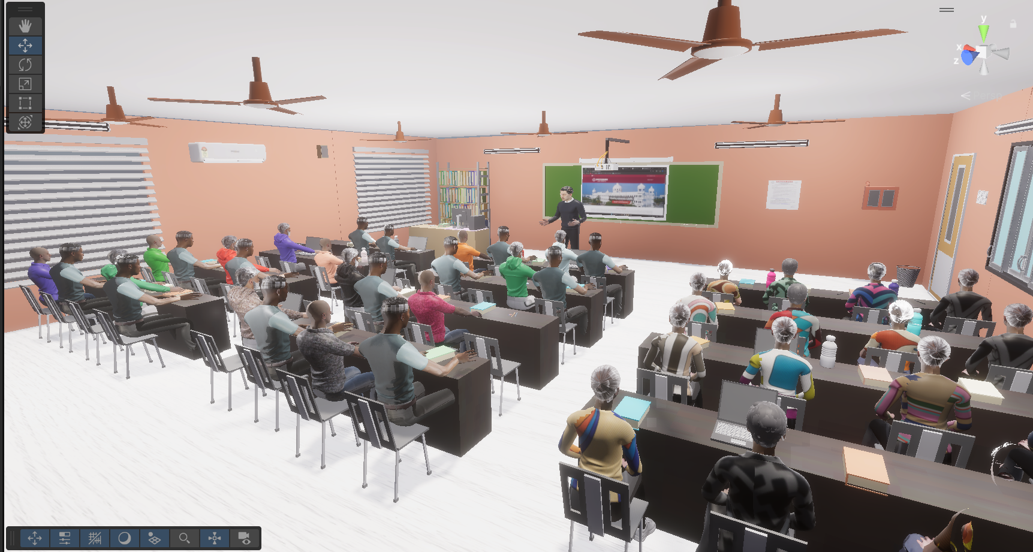 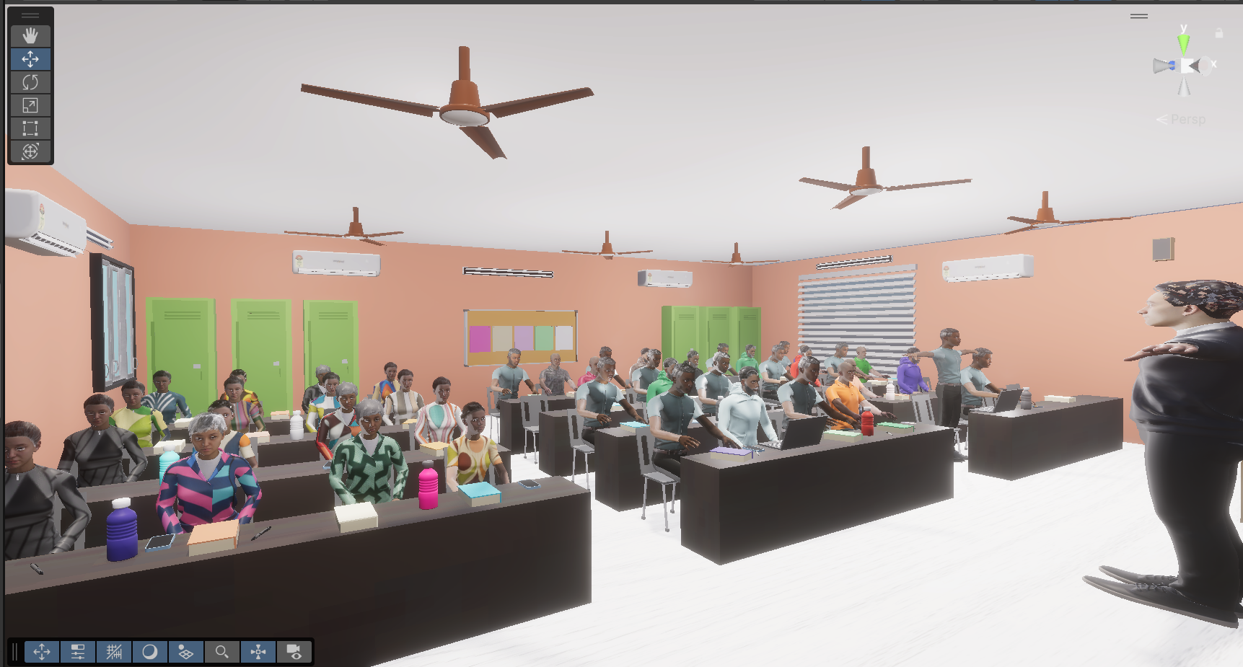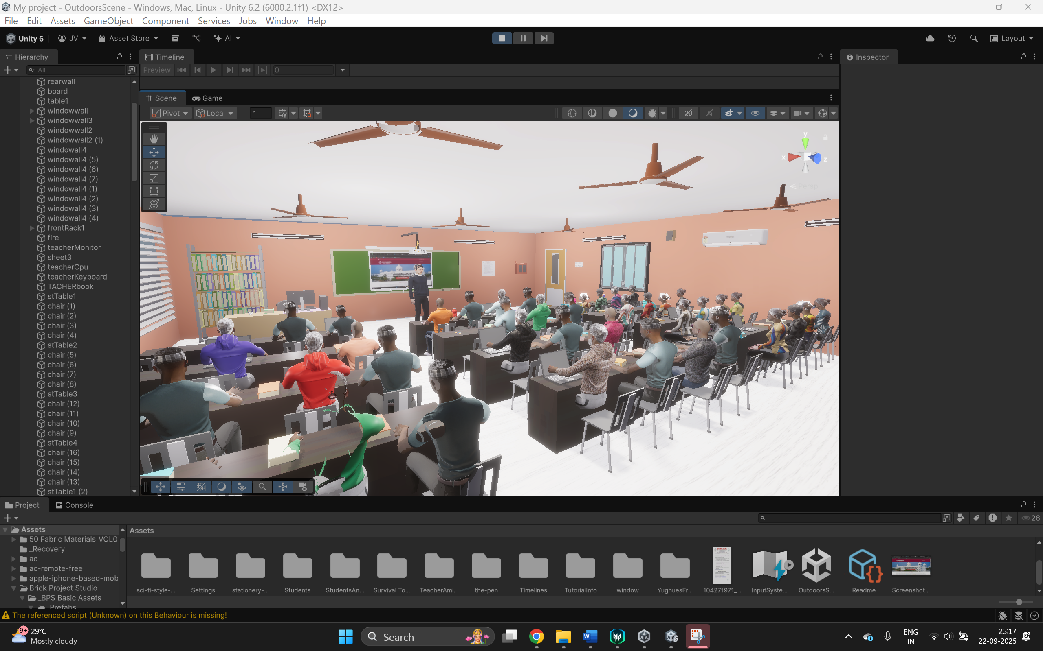

13

**CHAPTER 5**

**CONCLUSION**

The project “Implementation of Augmented Reality for Tutoring and Virtual Reality for Classroom Learning” successfully demonstrates how emerging technologies can enhance the learning experience. By integrating AR and VR into a unified platform, the system provides students with interactive, immersive, and engaging educational tools.

The AR Tutor Module allows students to visualize complex concepts in three dimensions, manipulate models, and receive real-time guidance, making learning more personalized and effective. The VR Classroom Module creates a fully immersive environment that simulates real-world classrooms, enabling students to attend lectures, interact with virtual objects, and collaborate with peers, regardless of physical location.

Through this project, it has been observed that AR and VR technologies can significantly improve student engagement, attention, and comprehension. The system is scalable, user-friendly, and compatible with widely available devices, making it suitable for educational institutions and remote learning scenarios.

In conclusion, this project not only bridges the gap between theoretical knowledge and practical understanding but also showcases the potential of immersive technologies to revolutionize education. It lays a strong foundation for future research and development in creating more advanced, interactive, and accessible learning platforms.

14